Template for departmental intranet post for PrideON. Please use this template and encourage your department to publish it on their intranet to spread awareness of PrideON.
The Civil Service LGBT+ Network is keeping PrideON.
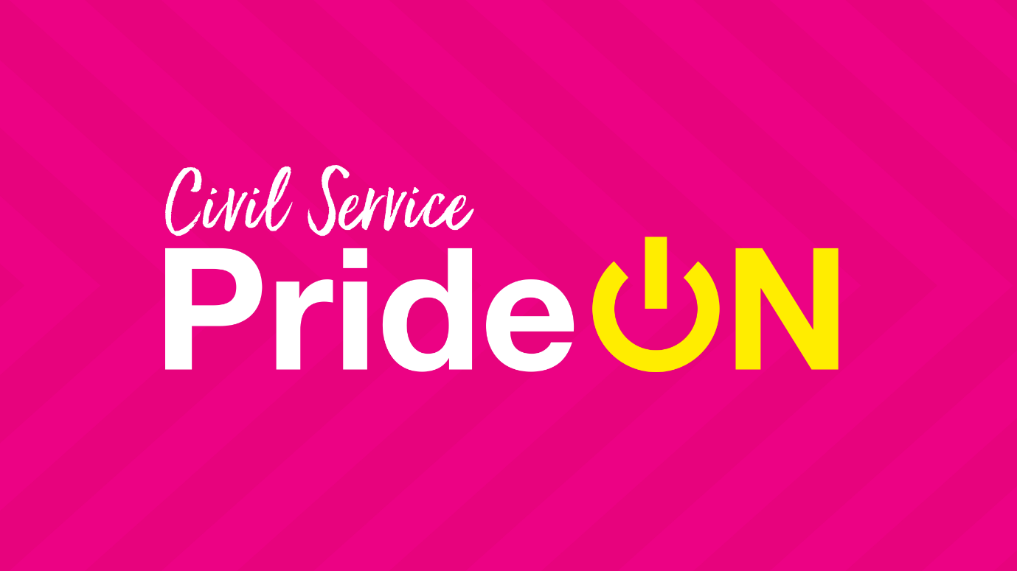
Pride is an important part of the LGBTI+ calendar. This year the events we would normally be celebrating together to recognise our LGBT+ colleagues and allies can’t go ahead in the same way, but here in [NAME OF DEPARTMENT] we are determined to make sure we celebrate our LGBT+ community.
The Civil Service LGBT+ Network has been working hard to keep PrideON in 2020 and with the help of their amazing members, have planned a programme of digital events and contents throughout June to celebrate Pride.
They have many exciting events planned such as a Big PrideON quiz, bingo, crafting activities, bake along, panel discussions and so much more. You can see the full calendar of events open to LGBT+ Civil Servants and Allies at www.civilservice.lgbt/pride. Be sure to check them out and sign up as some spaces are limited.
From w/c 15th June, they will be publishing digital content across all their channels. You will want to check out the PrideON playlist, the PrideON podcast and a set of blog posts on things that matter during the pride month. Also, keep an eye out for a famous face who has exclusively created some content for us all to enjoy. All content will be published on their website.
Make sure you are following their Facebook, Twitter and Instagram to keep updated with everything they are doing throughout the month and help celebrate our LGBT+ community.
Want to help spread visibility and show your support for LGBT+ Civil Servants?
The Civil Service LGBT+ Network has created a whole package of digital assets for you to use and share around your teams to promote LGBT+ visibility. You can download these and share them across social media, using the hashtag #KeepingPrideON. Show your support by adding their banner to your email signature, change your video call background on MS teams/ Zoom, or simply just share the resources around your team.

Are you hosting events to celebrate Pride during June?
Drop the Civil Service LGBT+ network an email to find out how they can help you.

Happy Pride month everyone, and together we will keep PrideON.
To find out more about the Civil Service LGBT+ Network, please visit their website.

